MX5 Vic&Tas logo(red)_OL

# **The Red & White Run**

Sunday, 17 May, 2015

This run starts at the McDonald’s, Berwick South. It covers approximately 75km.

The drive starts with a visit to the Old Cheese Factory in Berwick, where it all began for the Australian Mazda MX-5 Clubs with a gathering of 130+ cars on 6 May, 1990.

B*eware of cyclists, wildlife and local traffic.*

***Starting point:* McDonald’s, Berwick South (cnr Clyde Road & Homestead Road)  
(Melway 131 A12)**

***End point (C):* “Forest Edge” gourmet pizza, 2905 Gembrook-Launching Place Road, Gembrook (Melway 299 B6)**

***Radio:* UHF channel 24**

***Run leaders:* Murray & Alyssa – 0416 247 677**

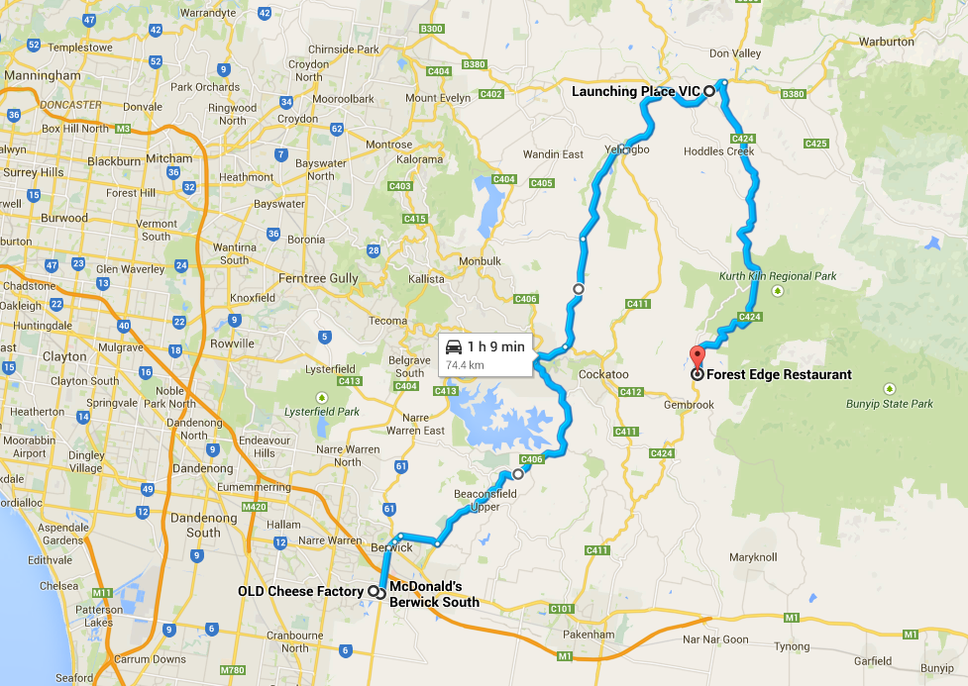

**Key:** SO - straight on • TL - turn left • TR - turn right • VL - veer left • VR - veer right

|  |  |  |  |
| --- | --- | --- | --- |
| **Odo reading** | **Action** | Detail | **Next direction** |
| **0.0** | **TL** | **Homestead Rd** | **km** |
| **0.2** | **SO** | through roundabout | **0.3** |
| **0.5** | **TR** | into **Old Cheese Factory** car park … park where you can and take a wander around the grounds (20 minutes) | **---** |
| ***Reset odometer as you leave the Old Cheese Factory car park*** | | | |
| **0.0** | **TL** | from car park into **Homestead Rd** | **0.3** |
| **0.3** | **SO** | through roundabout | **0.2** |
| **0.5** | **TL** | **Clyde Rd** *… bunch up into two lanes in Clyde Road so we get as   many as possible across Princes Hwy at the lights …* | **2.7** |
| **3.2** | **VR** | across Princes Hwy into **Lyall Rd, Berwick**  … *towards Harkaway* | **0.6** |
| **3.8** | **SO** | through roundabout *… Regroup on left if needed* | **0.5** |
| **4.3** | **TR** | at roundabout, into **Inglis Rd** | **2.3** |
| **6.6** | **TL** | at roundabout, into **Beaconsfield - Emerald Rd** [C406] | **17.1** |
| **23.7** | **TR** | at roundabout, into **Belgrave - Gembrook Rd** [C412] | **0.1** |
| **23.8** | **SO** | at roundabout | **2.1** |
| **25.9** | **VL** | into **Macclesfield - Woori Yallock Rd** [C406] | **13.6** |
| **39.5** | **TR** | into **Beenak Rd** | **0.3** |
| **39.8** | **TL** | at Yellingbo, into **Healesville - Koo Wee Rup Rd** [C411] | **5.3** |
| **45.1** | **TR** | at Woori Yallock, into **Warburton Hwy** [B380] | **4.7** |
| **49.8** | **TR** | into **Gembrook Rd** [C424] ***TAKE CARE!*** *Regroup on left if needed* | **18.6** |
| **68.4** | ***CARE*** | hairpin bend to left | **1.0** |
| **69.4** | ***CARE*** | hairpin bend to right | **2.9** |
| **72.3** | **TL** | into “Forest Edge” … park and move to the casual “pizza” section of the restaurant *(not the white-tablecloth dining area)* | |

**For BYO picnickers, there’s a great spot at “JAC Russell Park” (with BBQ & rotunda)**

* **From “Forest Edge”, continue towards Gembrook**
* **TR into Main Road, Gembrook [C412]; the park is in the town centre, 300m down on the right – next to Gembrook “Puffing Billy” station, Main Road, Gembrook (Melway 312 K10)**
* **Toilets are 500m down Redwood Road (opposite park), in the Gembrook Bushland Park**